**St. Thomas’ College of Engineering and Technology**

Industrial Training report on

**“GUESS GAME”**

Department of Information Technology

7th Sem , 4th Year

Group No. – 04

Group Member Roll No.

SAYAN GHOSH13

AKHILESH KR GUPTA14

SHIVAM HARSH 15

PRATIP KAYAL 16

**INDEX**

* About Project
* Technologies Involved
* Methodolgy
* System Design
* Screenshot of Application
* Future Scope
* Conclusion

**About the Project :**

In this project, we have created an android based Guess Game application.

Guess Game Application with Realm Database is used as a backend to store User Highest Score.

Each user can achieve their Score after Answering all the questions or after giving 5 incorrect answers.

User has to register with their name, Player can only see their score and the highest score at the end of the game. A player can choose the option between flower and animal from the home screen.

**TECHNOLOGIES INVOLVED:**

* Android Sdk(Android 9 API 29)
* Java Programming language
* XML

**METHODOLOGY**

To build this project we followed Waterfall Model.

* There is two modes to select from namely flower and animals.
* A user will lose if she/he gives multiple wrong answer which cross certain limit (5 is limit in this app).

In lieu of the requirements and the skills of the members the project was decided to be built on the Android Studio IDE using JAVA as programming language and Realm as the database.

* Coding/Implementation: The back end part of the project was written in JAVA.
* Deployment: The app is finally ready to be submitted as a completed project.
* Maintenance: N/A (unless required by the mentors).

**SYSTEM DESIGN:**

Our Guess Game Application design is following a sequence of steps through moving between different activities(question).

It starts with the main activity where users are provided their name and then they have to choose between flower and animal guess game.

Only the highest score will be stored in the database. The pre-existing player will have to enter the name before playing the game.

Each part (animal and flower) have 25 questions. Every player can give a maximum of 25 correct answers. If a player gives 5 incorrect in a single game the game will be over and the score of the current player shown in the screen with the highest score of the game.

**SCREENSHOTS OF APP**

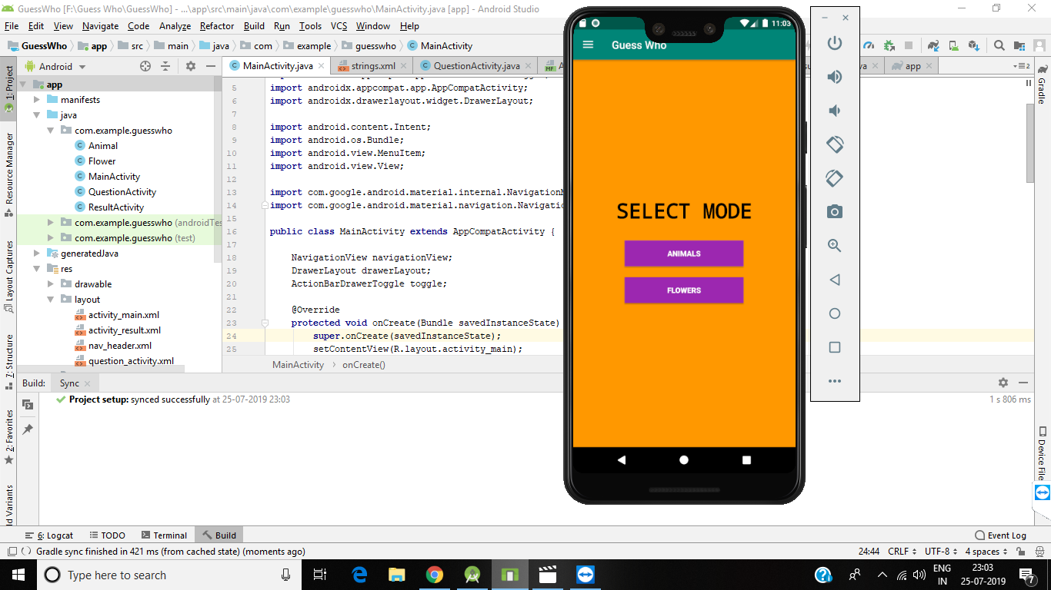

**FUTURE SCOPE**

As future projects, one can imagine many fields, not only directly concerning the Game Guess application. Of course, some minor adjustments have to be done to this app like if the player is giving the correct answer continuously then automatically the nest question is going to be tough then the previous one and if the player is giving an incorrect answer then the next question will be easy then the previous question. It should be ready to be deployed via the Android market. The UI could be polished a bit to match the design of modern mobile applications. Additionally, some system parts can be improved, mainly in the area of routing performance, to guarantee a smoother and faster experience for the user.

Nevertheless one of the big strengths of this project is definitely the amount of easily, reusable Java packages. As the whole code is open-sourced, all parts can be used to build other related game applications.

**CONCLUSION**

Several goals were accomplished while working on this team project. First of all an application was created which supports a user’s day planning with the following implemented functionalities:

* Generate a day plan, which is heavily optimized on completing as many tasks as possible.
* Simple, yet powerful task management system
* Continous checking of the dayplan’s consistency and compliance.

The task management functionality of this app is also strongly encapsulated and can therefore be reused easily in any Java project. The storage mechanism of converting tasks into events and storing them at a specific name can also be adapted easily to an Realm database or any other preferred storage solution.